# Paper Report-ENGG111_A2

Name- Tanwar Abhimanyue Singh UID- 3035392177

Email- [u3539217@connect.hku.hk](mailto:u3539217@connect.hku.hk)

**Screen Captures**

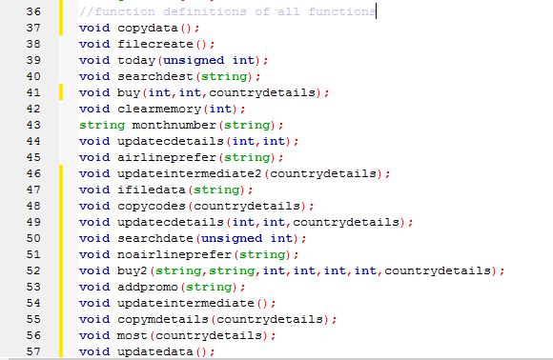 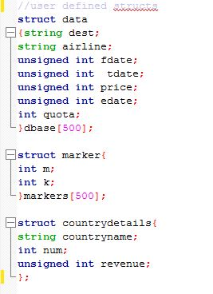

 

Global array

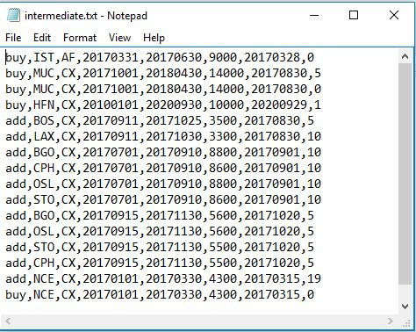 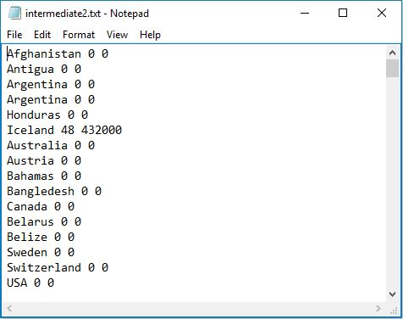

Intermediate File 1 Intermediate File 2

**INTERMEDIATE FILE DESIGN ANALYSIS:** I have two intermediate files in my program, the first stores all the updated commands in a sequential manner so that, every time program is run, the main database array can be updated with latest information. The second intermediate file stores the revenue and ticket details of every country, which is used for determining the most number of tickets. The pros of my design are that, since I am storing the commands in a sequential manner I have the access to big data and buying habits of consumers. This makes the program very flexible as the available information can be used to add other functions and enhance user experience while analysing the data available. My intermediate file design, adds new data at the end every time to update the information instead of remaking the whole file repeatedly, hence it prevents the hassle of producing file repeatedly. The cons of my intermediate file can be that sometimes, when there are so many commands or suppose, add promo file is too long, it can make my intermediate file a bit long, I realised a solution to this problem later, which is, instead of writing the name of every add deal in file, I can only write *add promo filename,* which will reduce the redundant add commands. Also I write a buy command every time, even if the same deal is bought repeatedly, I add new lines every time, instead of that I could have rewritten the quota every time for same buy command. My intermediate files increase the effectiveness of program in a manner that my program is really flexible, as all the data is available and changes can be made very easily without affecting the main logic. I copy the main database every time the program runs, hence, even if main database file is updated, my program would run normally as it does. My intermediate file 2 keeps a record of every country hence, this data can be utilised to provide smart suggestions to consumers.

**BONUS:** I have added a new feature called “minpricesearch”, which gives the minimum price out of all the searches to a particular destination. It helps the consumer to make the most economical decision while buying tickets! It works by sorting out the minimum price in the given search.

